

Artemis Financial Vulnerability Assessment Report

Table of Contents

Document Revision History 3
Client 3
Instructions 3
Developer 4
1. Interpreting Client Needs 4
2. Areas of Security 4
3. Manual Review 4
4. Static Testing 4
5. Mitigation Plan 4

Document Revision History

Version | Date | Author | Comments
1.0 | 07/13/2023 | Babatunde Ali-Brown

Client



Instructions

Submit this completed vulnerability assessment report. Replace the bracketed text with the relevant information. In the report, identify your findings of security vulnerabilities and provide recommendations for the next steps to remedy the issues you have found.

- Respond to the five steps outlined below and include your findings.
- Respond using your own words. You may also choose to include images or supporting materials. If you include them, make certain to insert them in all the relevant locations in the document.
- Refer to the Project One Guidelines and Rubric for more detailed instructions about each section of the template.

Developer
Babatunde Ali-Brown

Interpreting Client Needs

Financial companies often work with sensitive customer information as is the case with Artemis Financial which consults for customers on savings, retirement, investments, and insurance. This will require the storage and transmission of sensitive financial and personal information that must be protected from compromise and theft.

Although the scenario did not mention the implementation of international transactions, governmental restrictions about secure communications must be considered since Artemis Financial handle personal information sourced from governmental agencies, such as social security number.

Since hackers, of all sorts and from different server locations, are often seeking security vulnerabilities in the software systems of financial companies to steal valuable information sent during session requests and form completion, Artemis Financials’ software as it is currently and into the future must implement new security safeguards relating to HTTP security, session management, input validation, access control. Security safeguards must also be implemented to prevent database-related attacks such as SQL injection attacks.

According to the scenario, Artemis Financial wants to modernize its operations, and this must involve modification of its current system architecture to use software modules that are open source since open-source software provides opportunities to quickly expand operations with ready-made well-engineered software modules. This will require API interactions with third-party software and can present opportunities for attackers. Artemis Financial may also consider integrating cloud architectures into their current operation and security considerations must be applied in this area as well.

Areas of Security

Refering to the Vulnerability Assessment Process Flow Diagram and considering that Artemis Financials’ web application has a RESTful API based on the Spring framework and interacts with sensitive government sourced information, the following areas of security must be considered:
- Input Validation: Artemis Financials’ web application will receive input from customer through input fields and HTTP requests and this must be validated for data integrity.
- APIs: The Spring framework uses the API to interact between clients and the server as well as other third-party libraries or framework and security consideration must be put in place to safeguard the applications from vulnerabilities present using third-party software.
- Code Quality: Ensuring the reception of trusted data at the object/component level ensures security at the higher level.
- Cryptography: The use of insecure encryption protocols may compromise sensitive government-sourced data.

Manual Review

- GreetingsController.java requires input validation for the “name” query parameter.
- CRUDController.java requires input validation for the “"business_name" query parameter.

Static Testing

Below is a snapshot of the Maven Dependency-Check for the code base and some of the details on some of the vulnerabilities found on the National Vulnerability Database website @ https://nvd.nist.gov/.

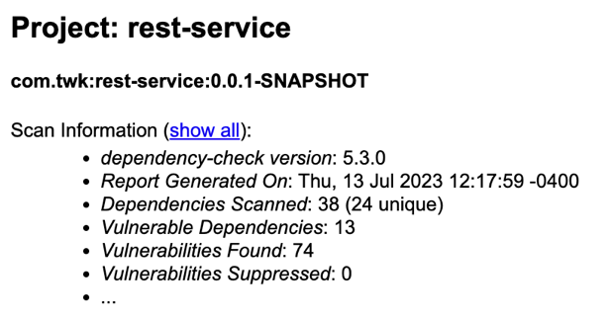 | 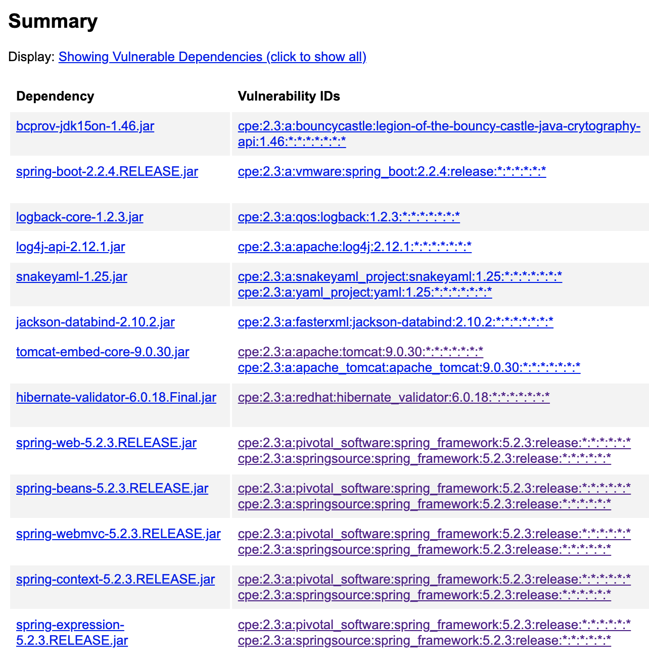

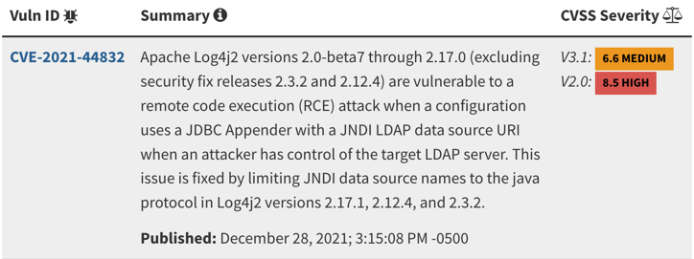  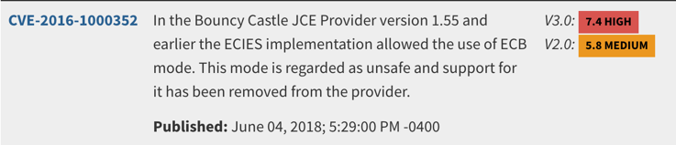  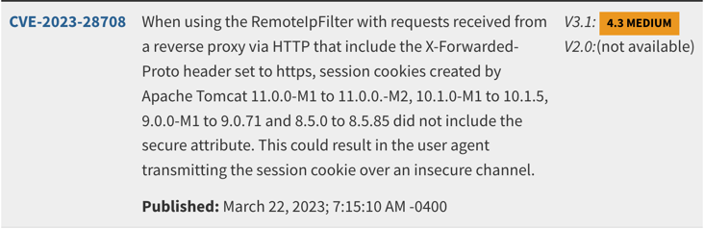 | 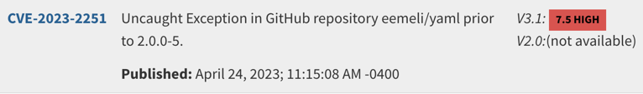  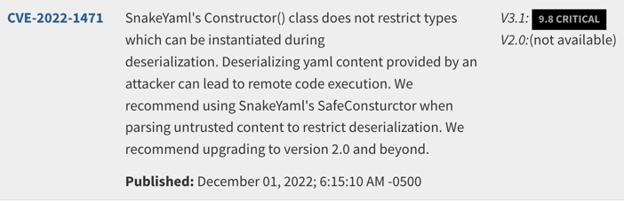

Mitigation Plan

Mitigation plan for the vulnerabilities found in the manual code review and static review is as follow:
- Fix the DocData.java class and ensure quality coding throughout the codebase.
- Research each vulnerability itemized in the dependency check and follow best recommendations to fix them.
- Code input validation into GreetingsController.java and CRUDController.java.

